Froggatt Awards Nomination Form

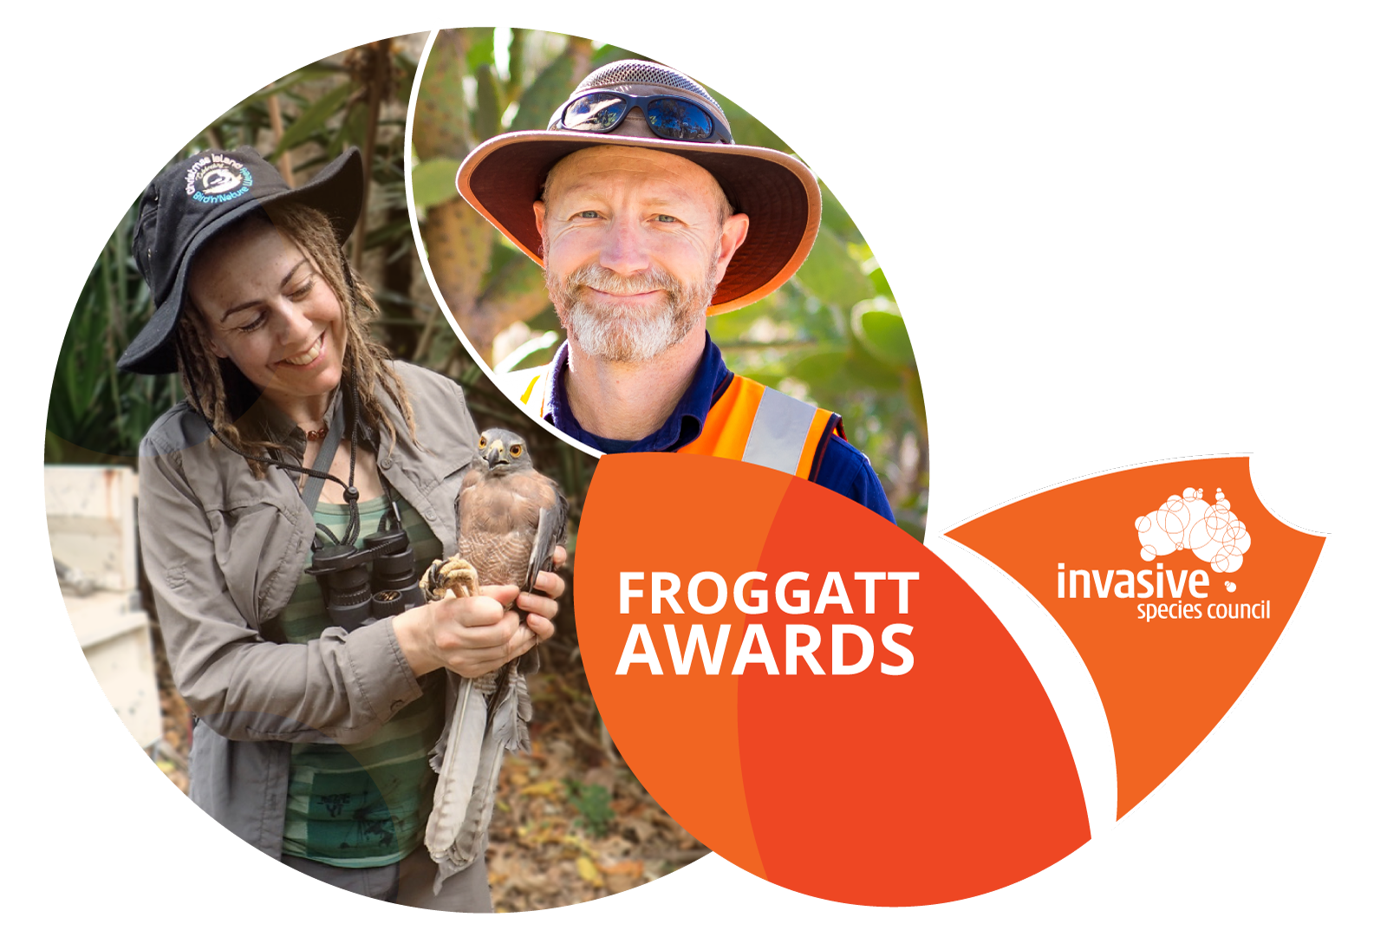
General information
Every year the Invasive Species Council recognises outstanding achievements in Australia’s fight against environmental weeds, diseases and pest animals through our Froggatt Awards.
Nominations are now open for this year’s awards.
Do you know an individual or organisation that deserves public recognition for their work protecting Australia’s native plants and animals from invasive species?
If so, please nominate them for a Froggatt Award using the nomination form below.
In the past our Froggatt Awards have gone to some incredible individuals and programs, including a young man who discovered a new infestation of yellow crazy ants in Lismore and volunteers who spent 10 years eradicating the weed sea spurge from Tasmania’s rugged southwest coastline.
Nominations close on 30 October 2021.

Criteria | Froggatt Awards  Awards will be given for significant achievement in reducing the threat to the Australian environment from invasive species.  Nominations will be assessed for demonstrated leadership, innovation, or exemplary biosecurity practices. Nominations for efforts that advance prevention or early action are particularly encouraged.
Scope | Any field of biosecurity (broadly defined), including policy advances, awareness raising, research and on-ground work. Efforts must relate to protecting the Australian environment from invasive species, including effort that has an international element. An invasive species can be an invasive plant, animal, or pathogen on the land or in the water.
Categories | - Control and eradication.  - Community advocacy.  - Policy and law.  - Principled decision-making.  - Research.  - Surveillance.
What you need to know | Nominations for the 2021 Froggatt awards are now open. To nominate an individual, group or organisation for a Froggatt Award you need to fill out the details in this nomination form, or use the online form.  To be nominated, an individual, group or organisation needs to have excelled in advancing the protection of the environment from invasive species.  Nominations close: 30 October 2021.  Award recipients are announced on our website in December.
To complete this form | - Enter data in all relevant fields.  - Expand text boxes if space is insufficient.  - Sign form and hit submit or print and then email or post.
Closing Date | 30 October 2021
Use our online form or print and post or email your application (form or emailed applications preferred) | Froggatt Awards  c/o Invasive Species Council  PO Box 818  Katoomba NSW 2780.  Email: isc@invasives.org.au
Nominee
- Nomination category
I am nominating in the following category (select applicable):
☐ Community advocacy.
☐ Control and eradication.
☐ Policy and law.
☐ Principled decision-making.
☐ Research.
☐ Surveillance.

- Nominee details
I am nominating (select applicable):
Individual
Group/Organisation
Details of the nominee as selected above
Name of nominee
(if an individual is nominated)
Name of group or organisation
Contact person
(if a group or organisation is nominated)
Phone (include area code) |  | Mobile phone
Email
Postal address
Suburb/town/city |  | State/territory |  | Postcode
Country

3. What has been achieved to significantly reduce the threat of invasive species to the Australian
environment?
Please explain what the individual or group/organisation has achieved to protect Australia's natural environment and/or native species from invasive species. Nominations for efforts that advance prevention or early action are particularly encouraged. Attach supporting information such as photos and evidence that clearly demonstrates the success of this achievement.

4. Why is this achievement significant?
Outline why this achievement is significant. Nominations will be assessed for demonstrated leadership, innovation, or exemplary biosecurity practices (max 500 words).

5. Nominator declaration
I declare that the information submitted is true.
I agree to abide by the eligibility terms and all other conditions outlined in the cover sheet.
I consent to the Invasive Species Council developing and using supplied images or videos for promotional purposes.
Nominator name
Organisation/Group
Relationship with nominee
Phone (include area code) |  | Mobile phone
Email
Date submitted (dd/mm/yyyy)

Terms and conditions
• When a Froggatt Award is presented, the information contained within the nomination form may be used by the Invasive Species Council for promotional purposes.
• The selection panel has absolute discretion in selecting award recipients and decisions are not subject to appeal.
• Individuals, groups and organisations can nominate themselves.
• Nominees can be more than one person, group or organisation for joint efforts.
• Individuals, groups and organisations may not be nominated for an award category they have previously received.
• A separate nomination is required for each category.
• Personal information collected will be securely held and used for contact purposes. Individual names may be publicised when the award is announced.
• Information in nominations will be treated as confidential until the awards are announced, after which the information may be publicly disseminated.
• Nominators are expected to assist with publicity of the achievements of the nominee.
• By making a nomination, you grant the Invasive Species Council a non-exclusive, indefinite right to use the information submitted, including any photos, for promotional purposes.

Privacy notice
'Personal information' means any information or opinion about an identified, or reasonably identifiable, individual.
The collection of personal information by the Invasive Species Council in this form is for the purposes of assessing nominations and presenting awards for the Froggatt Awards and related purposes, including contacting nominees and winners and related publicity. Personal information may be disclosed to the Invasive Species Council staff, contractors, a selection panel and published on the council’s website for these purposes.

